COVID-19 AND TOURISM
Institutional Affiliation
Student’s Name
Course
Date

Find a news article that discusses a particular market that has been affected by the Covid-19 crisis. This market should show a shift in demand (increase or decrease) or a shift in supply (increase or decrease), or both. Include a title, link, or pdf of the news article you found. Be sure to use a reliable news source and avoid macroeconomic topics (unemployment, GDP, etc.) and articles about the stock market.
In the tourism market, the coronavirus pandemic led the demand curves for tourism to change to the left, but the tourism supply curve remains the same. The price and volume of tourism are declining. The demand curve for goods is downwards, which shows the reverse correlation between the good and the demanded amount. The good direct relation between the price of the good and the quantity needed, on the other side, a supply curve.
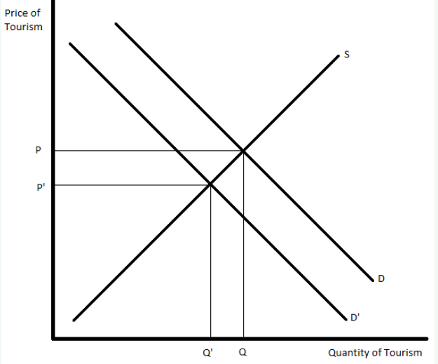
With the information you know about economic principles and the supply and demand model, briefly analyze what is happening in this market. The article may give you some clues as well. It may help graph the change in this market, although that does not need to be part of your response.
Coronavirus is the lethal virus of recent months that has ravaged the world. The social distancing government protocol to prevent coronavirus transmission has seriously affected the tourism industry. Tourism demand market elasticity is elastic. The tourism supply appears to be equal, but the tourist demand is falling because, at the coronavirus pandemic, people do not prefer tourism. The decline in tourism demand induces a left-hand change in the tourism demand curve, decreasing tourism prices and quantities. It can be seen as the above, graphically:

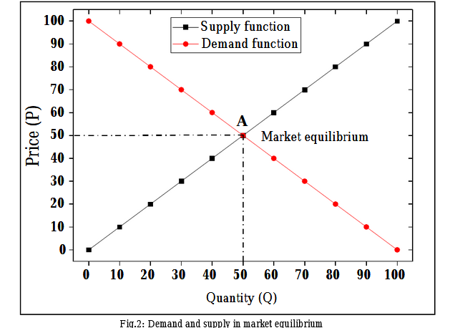
The above figure Shows the tourist supply and demand curve for the Sector in the state of price equilibrium. The balance means that the bid price is 50 for the provided quantity of 50 (point A). Price equilibrium is a market that balances The condition where the consumer supply is equal to the demand For the market. The price of equilibrium is the cost of a good Or operation if its production is equal to the business's demand. Economic equilibrium in economics is a balance. A scenario where economic forces such as production and supply are concerned In the absence of external production, demand is balanced. It would not affect the prices of economic variables (Uğur & Akbıyık,2020).
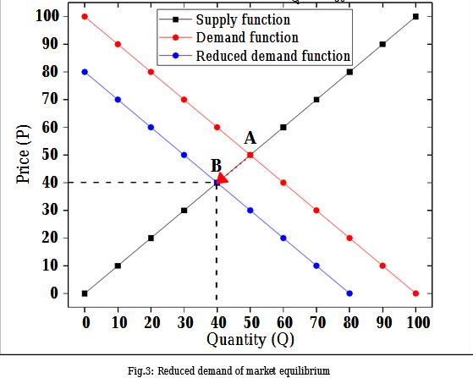
The above figure indicates the price equilibrium shifts after In demand function, the decrement change. The Fresh Market Equilibrium is at a price between equilibrium of 40 and equilibrium The quantity expressed by point B is 40. modern market equilibrium in equilibrium indicates that the equilibrium price value reduces. The sum and equilibrium of the change in demand function is a result of the COVID-19 epidemic.
Compose a response to the following: Describe your market and what change has occurred. What underlying factor has changed the market? Which curve is affected--supply or demand? Which way is the shift--an increase or a decrease? According to the model, what should we expect concerning price and quantity? In reality, did the market react the way the model would suggest? If not, why not? Remember that models are helpful to explain and predict things, but they don't always mirror reality.
The tourism market's essence, the effect of travel restrictions on tourist flows, the scale of the domestic tourism sector and exposure to foreign source markets, and the position of tourism in the economy are the fundamental factors that impact the market. The supply curve is greatly affected by the covid-19 since there is a restriction in traveling across countries and regions. The supply curves shift downwards, depicting a decrease in the rate of tourism visits in a country. Since there is decreased supply of foreign currency, there is a tendency to reduce the quantity and increase prices. This is precisely what happened in reality, just like the model has suggested.

The article Title
Impacts of COVID-19 on global tourism industry: A cross-regional comparison
Link
https://www.sciencedirect.com/science/article/pii/S2211973620301112

Reference
Uğur, N. G., & Akbıyık, A. (2020). Impacts of COVID-19 on global tourism industry: A cross-regional comparison. Tourism Management Perspectives, 36, 100744.

